**Computer Engineering Dept.**

**D12A**

**Synopsis Document**

|  |  |  |
| --- | --- | --- |
|  | **Name of the Project** | Face Recognition Based Attendance Management System |
|  | **Objective/ Vision** | 1. Trying to ﬁnd a face within a large database of faces. In this approach the system returns a possible list of faces from the database. The most useful applications contain crowd surveillance, video content indexing, personal identiﬁcation (example: drivers license), mug shots matching, etc.  2. Real time face recognition: Here, face recognition is used to identify a person on the spot and grant access to enter in to any organization, thus avoiding security hassles. In this case the face is compared against a multiple training samples of a person. |
|  | **Users of the System** | A. College Faculty  B. Users of the application(Students and Teachers)  C. Any Organization |
|  | **Review** | Based on your problem statement, review from existing work.  Previous work ( Refer : <https://www.bennett.edu.in/arsha-attendance-recognition-system-using-half-face-appearance/>) |
|  | **Functional Requirements**  **(Atleast Eight)** | * The user should be provided with updated information of the suspected images or culprits. * The admin is given a provision to check his account information and change the account information any time. * The user can get the information about the images or videos which are placed in front of camera. * The admin is provided with interfaces to add/delete the characteristics of the information available in the database. * The system uses internet to interconnect with the surrounding systems for efficient matchup. * The system allows the user to log in by using username and password given default as “admin”. * The system allow user to input image to be matched. * The system allows image to be compared. |
|  | **Non-functional requirements (At least Four)** | * The data stored can be encrypted locally to protect from any local copy or theft of device (laptop/handheld device). * Validating the platform independent format before inserting it into the centralized repository (database). * Confidentiality of Users data is to be maintained * Data integrity is essential for better classification. * User interface should be simple and easy to interpret. * It should support 24/7 availability. |
|  | **Optional features** | A method to automatically connect to webservice if network is found. |
|  | **User interface priorities** | A. Professional look and feel  B. Easy to data entry in system to fast detect so that less wastage of time in recoginition |
|  | **Reports** | Reports customizing the stored data in a platform independent format and displaying it using style sheets. |
|  | **Other important issues** | A. The architecture should be highly scalable and the mobile web   app should be tuned for better performance even during peak times.  B.The web app should be highly customizable and flexible   enough to easily deploy. |
|  | **Team Size** | 4 members |
|  | **Technologies to be used** | * Python, Android, Java , OpenCV, Matlab, C/C++/C# |
|  | **Tools to be Used** | * [Google Facial Expression Comparison](https://lionbridge.ai/datasets/5-million-faces-top-15-free-image-datasets-for-facial-recognition/) * [UMDFaces](https://lionbridge.ai/datasets/5-million-faces-top-15-free-image-datasets-for-facial-recognition/) * MySQL * Firebase * Any Camera |
|  | **Final Deliverable must include** | A. Prediction of users attendance using proper visualization techniques and displayed in application.  B. Reports based on entry and exit of applicant.  C. Database backup  D. Records generated with respect to various end user’s perspective and it is customizable. |
|  | **Example scenarios** | * Data of entry and exit. * Only half face detection is used. * Attendance is directly entered in database. * Students and Teachers both can use the same system. |

**Conceptual Diagram**

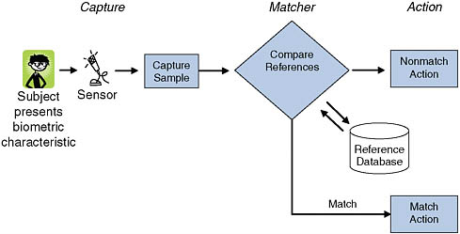

**Date :**

**Mentor’s Signature:**

**Group Members(Roll.no & Names):**

1. **Sagar Sidhwa(Roll No. 62)**
2. **Somesh Tiwari (Roll No. 71)**